Boosting Sales with the Cloud: Information System Approval Submission

John Wensink

MIS350 – Information System Analysis and Design)

Colorado State University-Global Campus

Dr. William Willette

March 29, 2018

**Consumer Sales Information System in the Cloud**

Hello and thank you for your time. For the past few months, our team has been researching what we believe to be a next-generation information delivery system that will carry our company into the coming decade. In this proposal, my goal is to convince the members of this committee that our team’s plan to use a third-party’s “software-as-a-service” (SaaS) hosted in cloud-based servers, is the optimal solution for our organization's data system requirements. I understand you are considering various proposals from the different departments of the enterprise. While I respect the diligent and tireless work contributed by our colleagues, in this proposal I will show using cost/benefit analysis that the cloud-based systems proposal using software as a service is the logically superior option.

**Trends**

As the 2010’s come to a close we are presented with an opportunity to gain insight about the nature of modern commercial data delivery systems, and the consumers who rely on them. A study by IDG Communications Inc. (2018) has shown that cloud-based technology has rapidly overtaken other more traditional means of delivering an information system. In fact, the study found that nine out of ten businesses surveyed had at least one system in use that was based in the cloud (or had plans to acquire one in less than one year.) 73% already had cloud-based systems, with 17% planning on acquiring these systems. The study found that just 10% of the 550 IT managers interviewed had no plans to use cloud-based data systems.

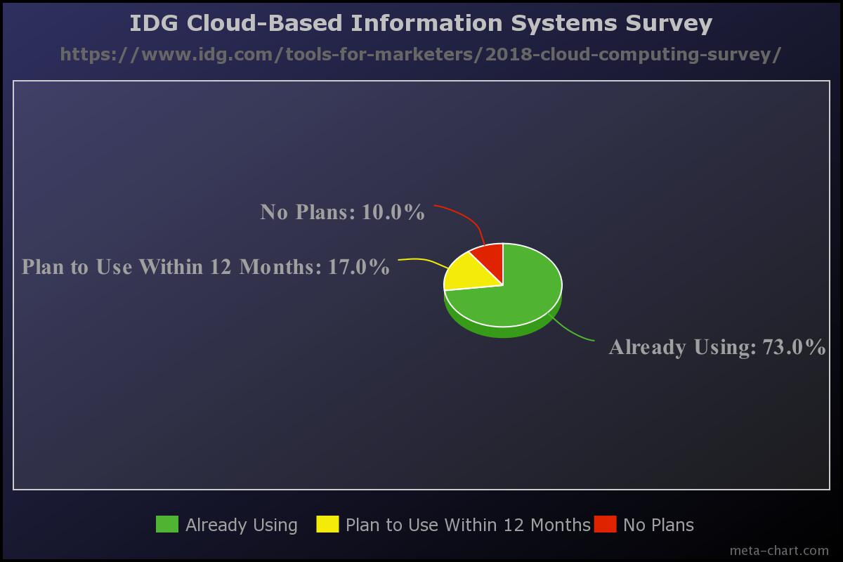

When we look at the results of this survey we see not only that the adoption of SaaS is growing, but also other areas of cloud-based data delivery such as “Infrastructure as a Service” (IaaS), “Platform as a Service” (PaaS), as well as spending for all three specializations rose sharply throughout the last decade. It is clear that companies are finding value in hosting their data delivery systems in the cloud. The survey also found the types of operations that were occurring in the cloud consisted of various operations related to hosting, collaboration, and backing up critical data.

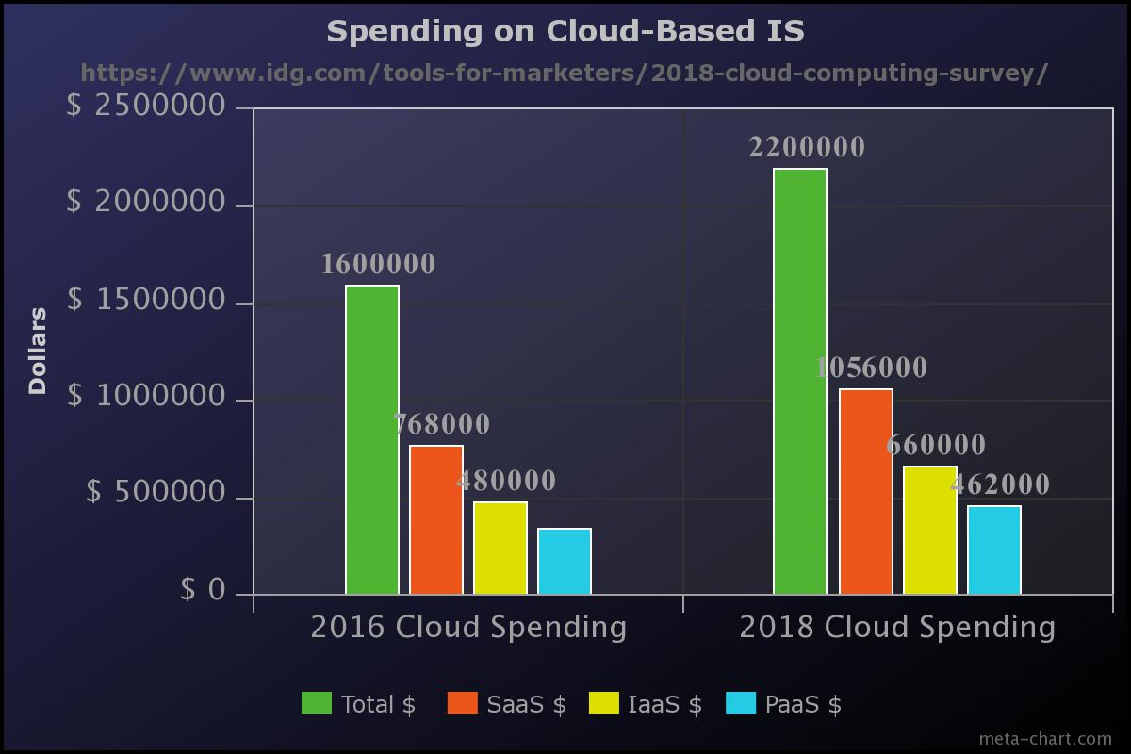

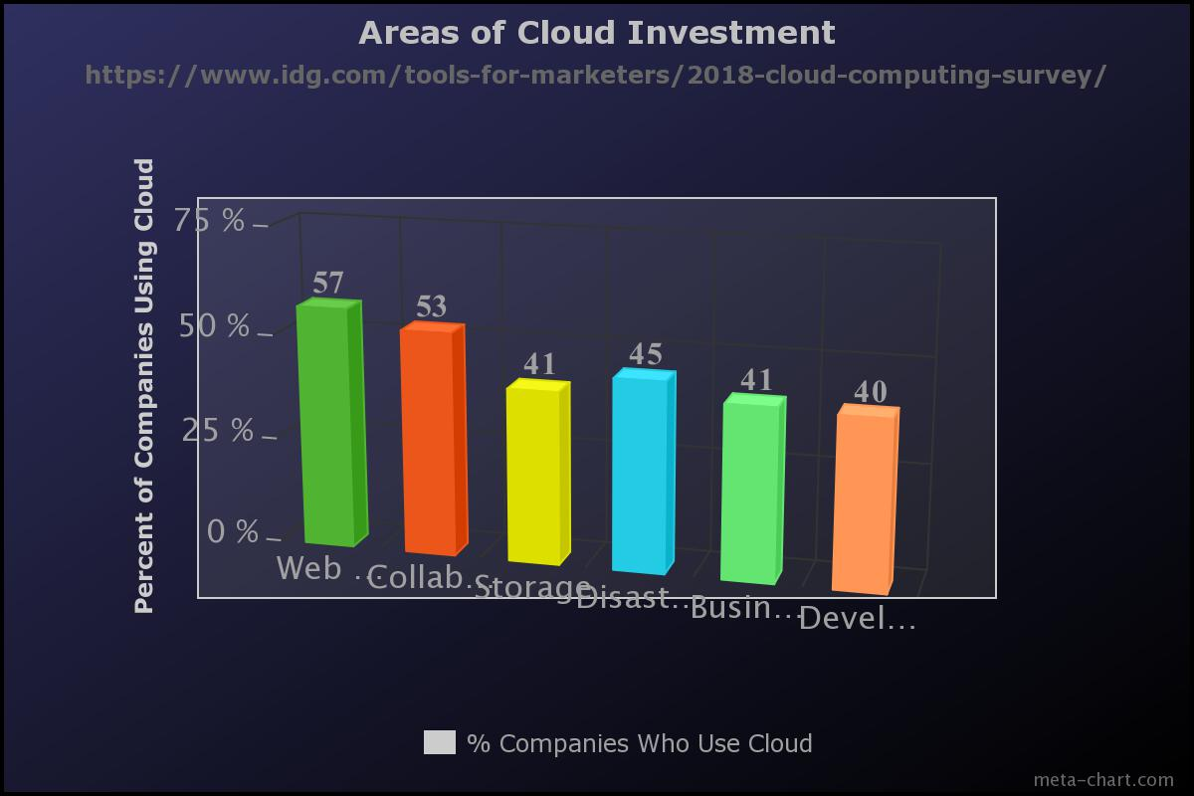

**Tangible Benefits**

Working closely with the CFO, my team has calculated the potential benefits that implementing a cloud-based data system could bring to our organization. Return on Investment, payback period and net present value are some of the tangible benefits that our business can calculate to help understand the merits of each proposal. For convenience, we have composed a benefit forecast showcasing several areas in which the company stands to benefit from implementing this SaaS data system. The areas are:

|  |  |
| --- | --- |
| Monthly New Customers | 213 Customers |
| Monthly Sales from New Customers | $90,000.00 |
| Monthly New Leads | 368 Leads |
| Lead-to-Sale Conversion Rate | 58% |
| Cost-per-Lead | $53 |
| Cost-per-Conversion | $478 |
| Customer Lifetime Profitability | $35 |
| Attrition Rate | 3.5% |
| Average Conversion Time | 4.5 Days |

(Karlson, 2018)

By implementing a cloud-based data system our company would have the best chance at improving these numbers in a substantial, meaningful way. By conducting a value-chain-analysis we can determine the cost/benefit to implementing a cloud-based information system.

**Costs**

One of the main benefits of using SaaS is its relatively lower cost to use compared to other development avenues like developing an in-house system or purchasing a “commercial off-the-shelf.” (COTS) With a monthly subscription, our company is able to all but eliminate some categories of costs such as the high price of owning a physical server, or expensive training programs. We have worked out a cost table we believe to be an accurate representation of the monthly cost-to-own a fully functional information delivery system.

|  |  |
| --- | --- |
| Sales System Users | 10 Users |
| Subscription Fee per-month/user | $170 * 10 users * 12 months = $20,400/Year |
| Server Ownership Costs | $0 |
| Training Fees | Labor Time + $0 |

(Karlson, 2018)

From this cost table, we are able to calculate several key metrics including the yearly cost to use, cost per employee, and see that by using a cloud-based information delivery system we can completely eliminate some areas of cost such as training fees and server ownership costs. Our research indicates that our sales team could operate approximately 14.8% more cost efficiently (Δ = 0.148) per year, with the efficiency becoming more pronounced with every passing year

(Γ = 0.043) From this research, we have extrapolated nine key sales metrics to represent what we believe is an accurate forecast of our sales number should this strategy be implemented. We calculated ROI to be greater than 4:1 and expect the ratio to improve year after year. 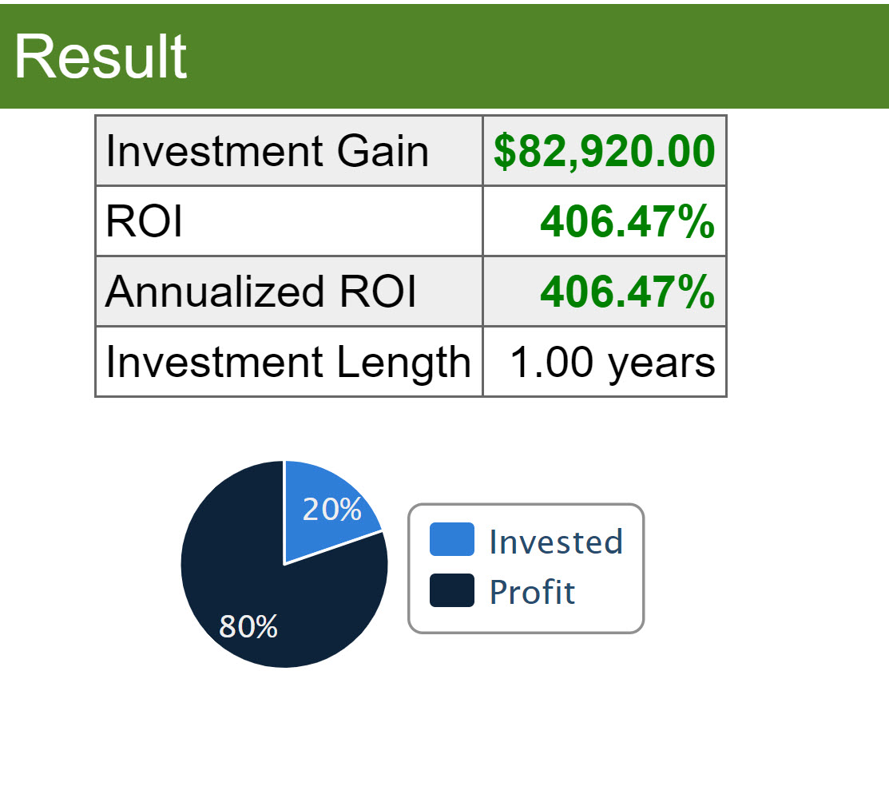 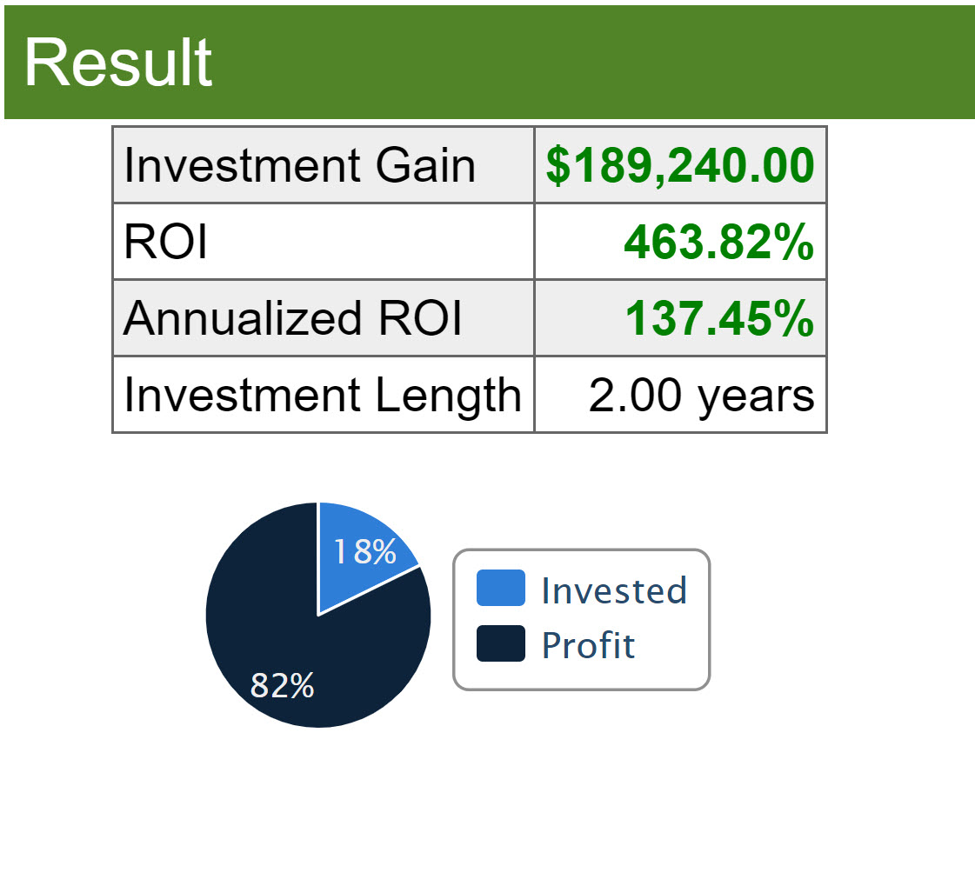

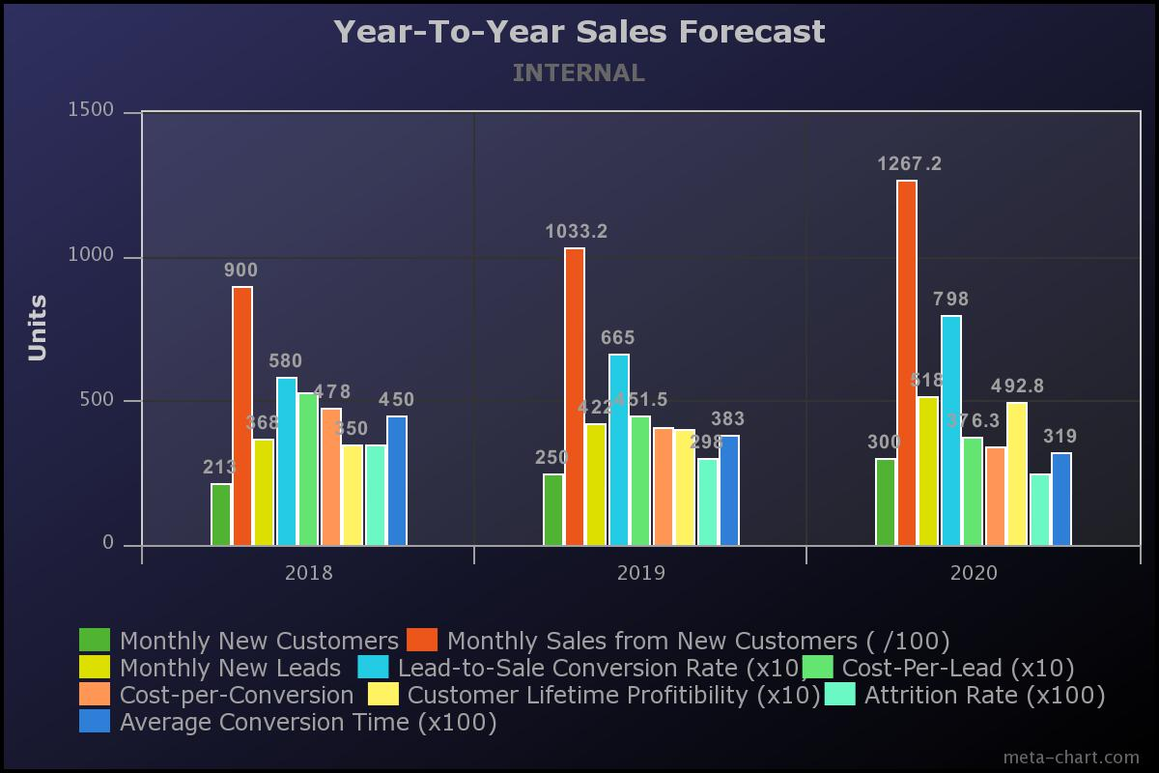

From this data, we can see that the benefit of implementing a cloud-based data delivery system would be rapid and substantial, with a payback period of right around one fiscal quarter.

“Net Present Value” (NPV) is calculated by using the formula:

NPV = F / [ (1 + i)^n ]

Where, PV = Present Value, F = Future payment (cash flow), i = Discount rate (or interest rate)

n = the number of periods in the future the cash flow is. (CFI, n.d.) If we implement this strategy it is clear that our business will grow and most SaaS vendors will allow for discounted rates for more usrs. Let’s imagine a conservative 5% discount each year we grow in size. NPV after two years would be $268,494.07.

**Indirect Benefits**

It is important to realize that dollar value is not the only advantage of using a cloud-based information system. Many businesses that have implemented it recently have described increased agility and flexibility when conducting business transactions. These indirect benefits add value to our organization that is harder to quantify but will have an impact on things like overall customer satisfaction, employee experience, as well as enterprise adaptation to changing times. Other indirect benefits are things like reducing the workload on our IT department so that they can focus their attention on problems that there hasn’t been time or labor power for in the past. In addition to a system that works in today’s business environment, we can expect robust update support to provide our enterprise’s SaaS system with the latest and greatest features available on the commercial market.

**Recommendation**

After researching the costs and benefits associated with implementing a cloud-based system, it is my sincere recommendation that this project is given the green light to receive funding and eventual deployment. I believe the world is trending towards cloud-based information delivery systems and it is important to be able to adapt to a changing business environment. As you have seen the cost/benefit of employing such a system suggests that its immediate implementation would bring substantial profit in the short, mid, and long terms. It is, for this reason, it is my sincere recommendation that our organization takes the steps necessary to begin to migrate our current data delivery system for new cloud-based software as a service system so that we may continue to thrive. Thank you for your consideration.

References

CFI. (n.d.). NPV Formula - Learn How Net Present Value Really Works, Examples. Retrieved March 31, 2019, from <https://corporatefinanceinstitute.com/resources/knowledge/valuation/npv-formula/>

IDG Communications Inc. (2018, August). 2018 Cloud Computing Survey. Retrieved March 31, 2019, from <https://www.idg.com/tools-for-marketers/2018-cloud-computing-survey/>

Karlson, K. (2018, November 29). 16 Sales KPIs that Every Team Should Measure. Retrieved March 31, 2019, from <https://www.scoro.com/blog/sales-kpis-for-executive-dashboard/>

Llave, K. A., Dávila, A., & Pessôa, M. S. (2016). Information technology service management models applied to medium and small organizations: A systematic literature review - Semantic Scholar. Retrieved March 24, 2019, from [https://www.semanticscholar.org/paper/Information-technology-service-management-models-to-Llave-Dávila/3b78af0befddd5802ee878f77dd88f6671e3185f](https://www.semanticscholar.org/paper/Information-technology-service-management-models-to-Llave-D%C3%A1vila/3b78af0befddd5802ee878f77dd88f6671e3185f)

Sandanayake, T., & JayanganiLink, P. C. (2018, November 2). Current Trends in Software as a Service (SaaS). Retrieved March 24, 2019, from <http://ijier.net/ijier/article/view/969/713>